Voucher Hunt
How it works — a short guide for businesses considering the app
This covers the two things that happen every day: a customer winning and booking a voucher, and your staff accepting it at the counter. No technical knowledge needed, and about five minutes to read.

The idea in one paragraph
Customers open the app, pick your campaign, and spin for a discount — 20% off, 50% off, a free dessert, whatever you decide. Winning is only half of it: to keep the voucher they must book a specific date and time, so the discount fills the tables you choose, not your Friday night rush. When they arrive and pay, your staff scan the code, and the customer automatically earns Loyalty Points worth 5% of what they spent — which they can spend back with you later.

Part 1 — The customer journey

Step 1 — Find a campaign
The customer opens the app and sees every live campaign: your business name, your photo, your location, and the dates the offer runs. They can search or filter by category — Restaurant, Online Shop, Beauty, and so on. Campaigns that are fully booked stay visible but are marked as such, so your business keeps its presence even on a busy week.
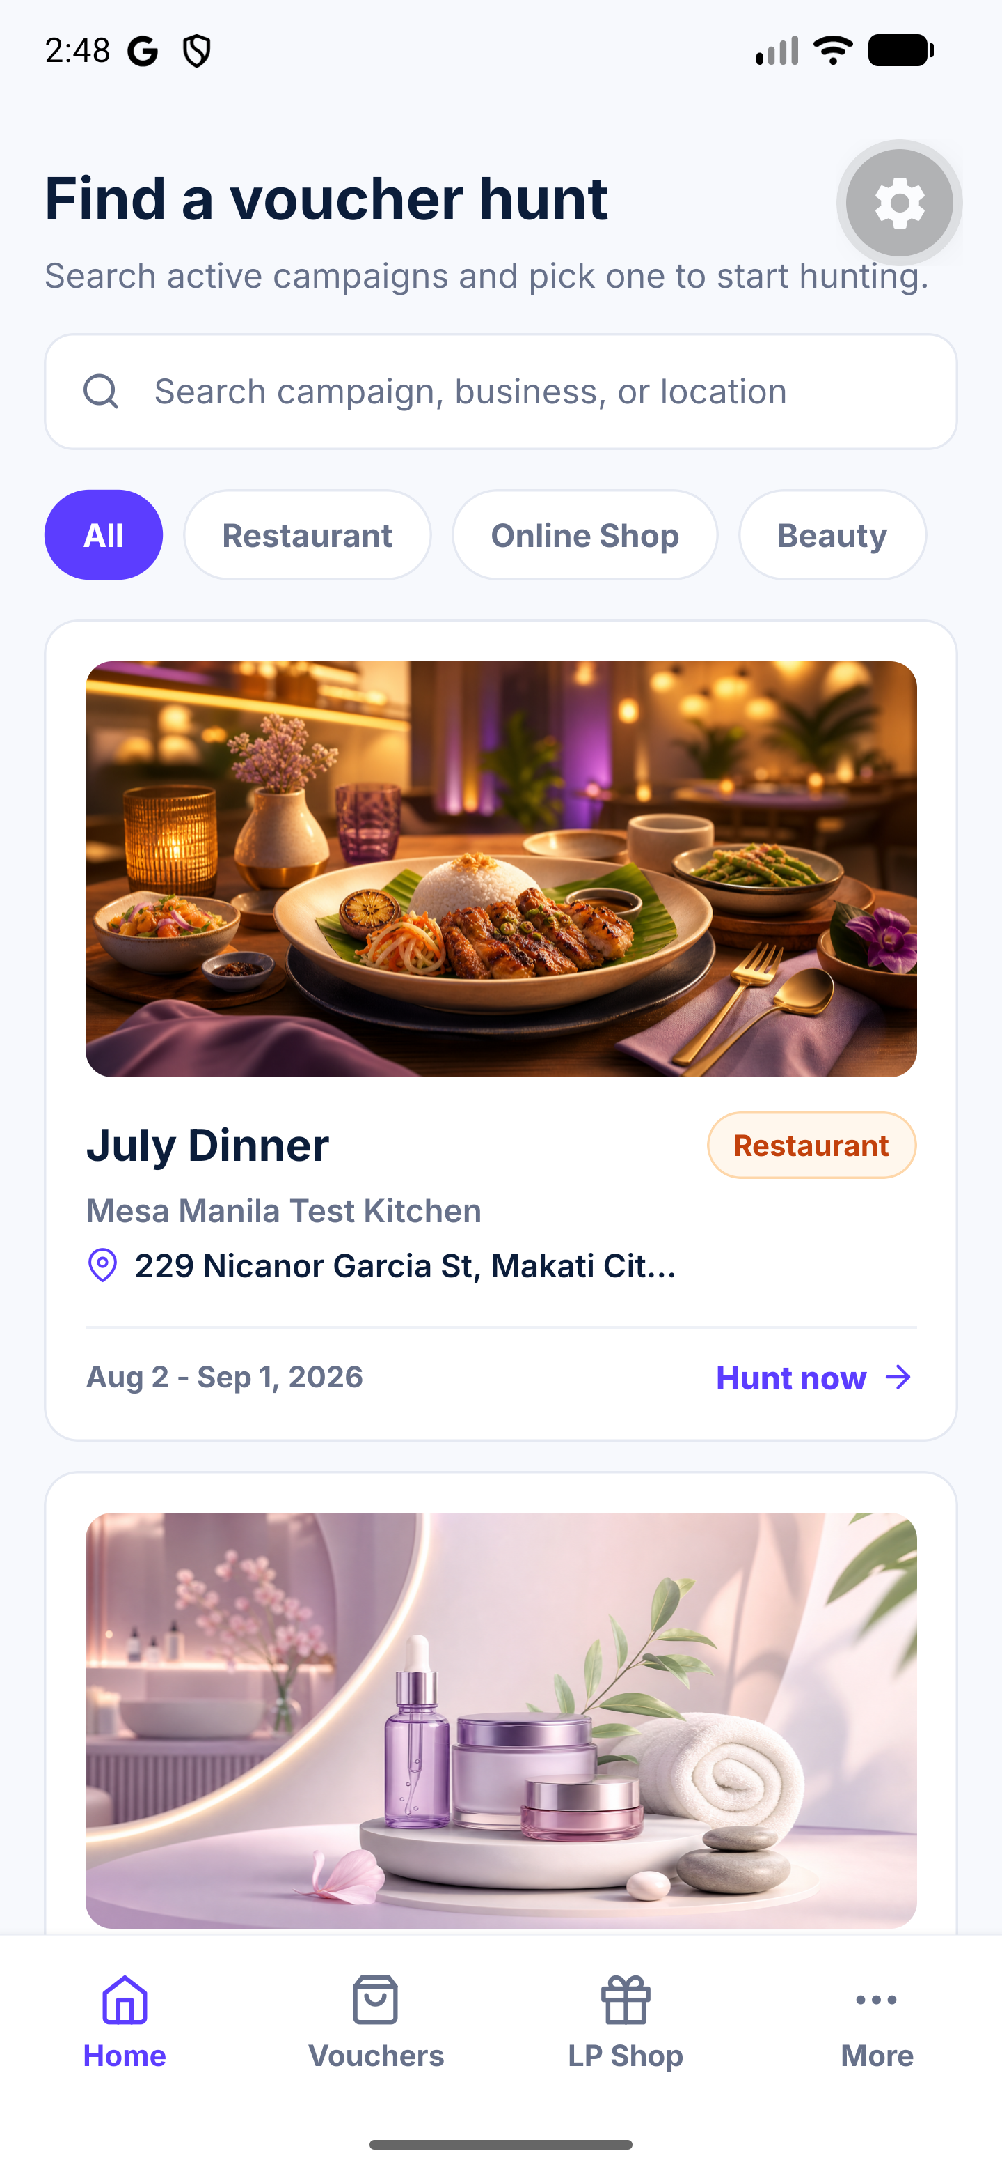
The Home tab, showing live campaigns

Step 2 — Sign in with a mobile number
First time only. The customer enters their mobile number and types in the six-digit code we text them. No passwords, no account to remember — and it ties every voucher to a real, reachable person.

Step 3 — Start the hunt
The campaign page shows the offer, the rules, your address, a map, and a phone number to call you. One tap begins the hunt. You set how many spins each customer gets in a campaign — three is the usual — and they can earn a few more by sharing a referral link, capped daily, so it stays a game rather than a loophole.
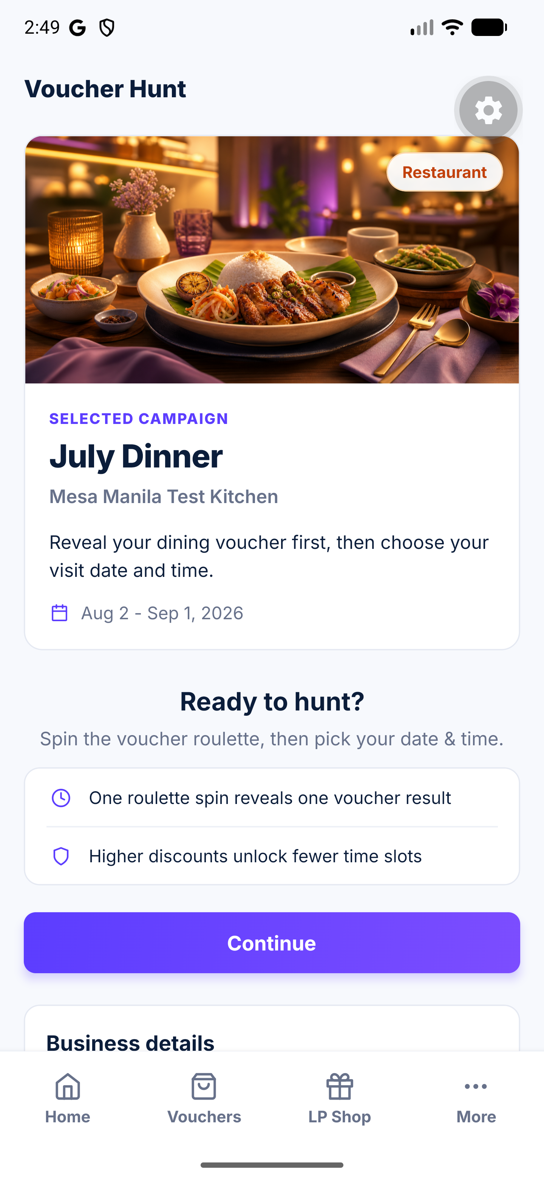
A campaign page, ready to start

Step 4 — Spin and win
The reel spins and lands on a real prize from your campaign — say 30% off. The odds are yours to set: you give each prize a rarity, from Standard through to Legendary, and that alone decides how often it comes up. A Legendary prize is drawn a fiftieth as often as a Standard one.
- The app never offers a prize it cannot honour. If a tier has run out, or has no bookable time slots left, it is quietly taken out of the draw. Nobody wins something they cannot use.
- Spins add up rather than replace. Every spin they take adds another prize to choose from, and they keep whichever they like best. Spinning again costs a spin, never the prize already in hand.
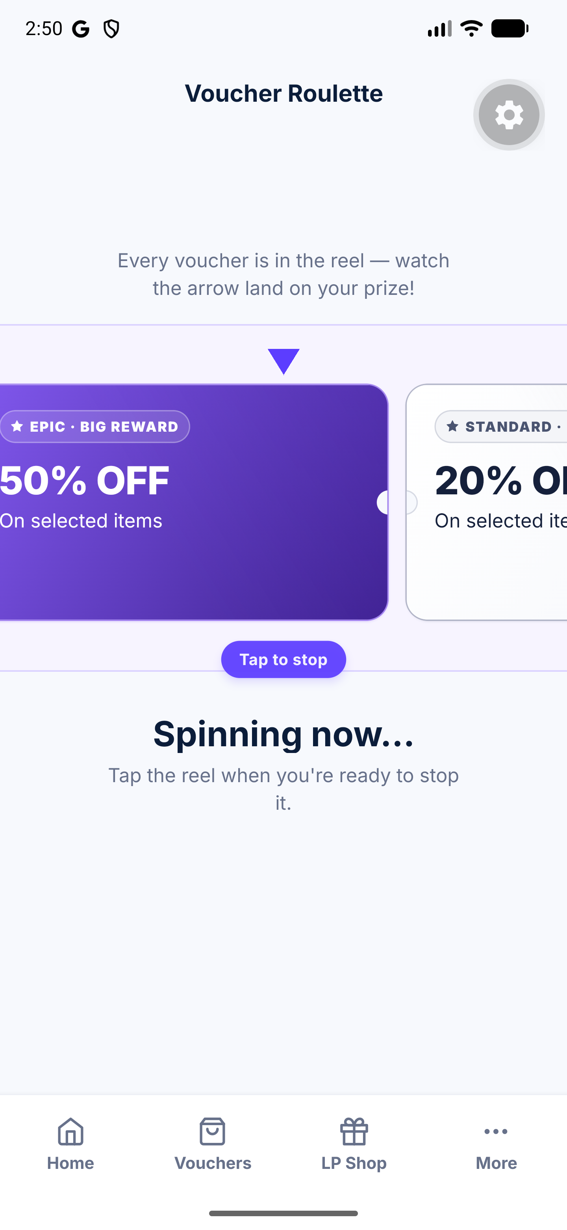
The reel mid-spin

Step 5 — Pick a date and time
This is the part that makes the offer work for you. The customer picks from the slots you opened — the quiet Tuesday lunch, the 2pm off-peak table — and each slot has a set capacity. When it is full, it shows as sold out. You can also restrict your best prizes to your quietest slots: a 90% off tier might only ever be bookable at 2pm on a weekday.
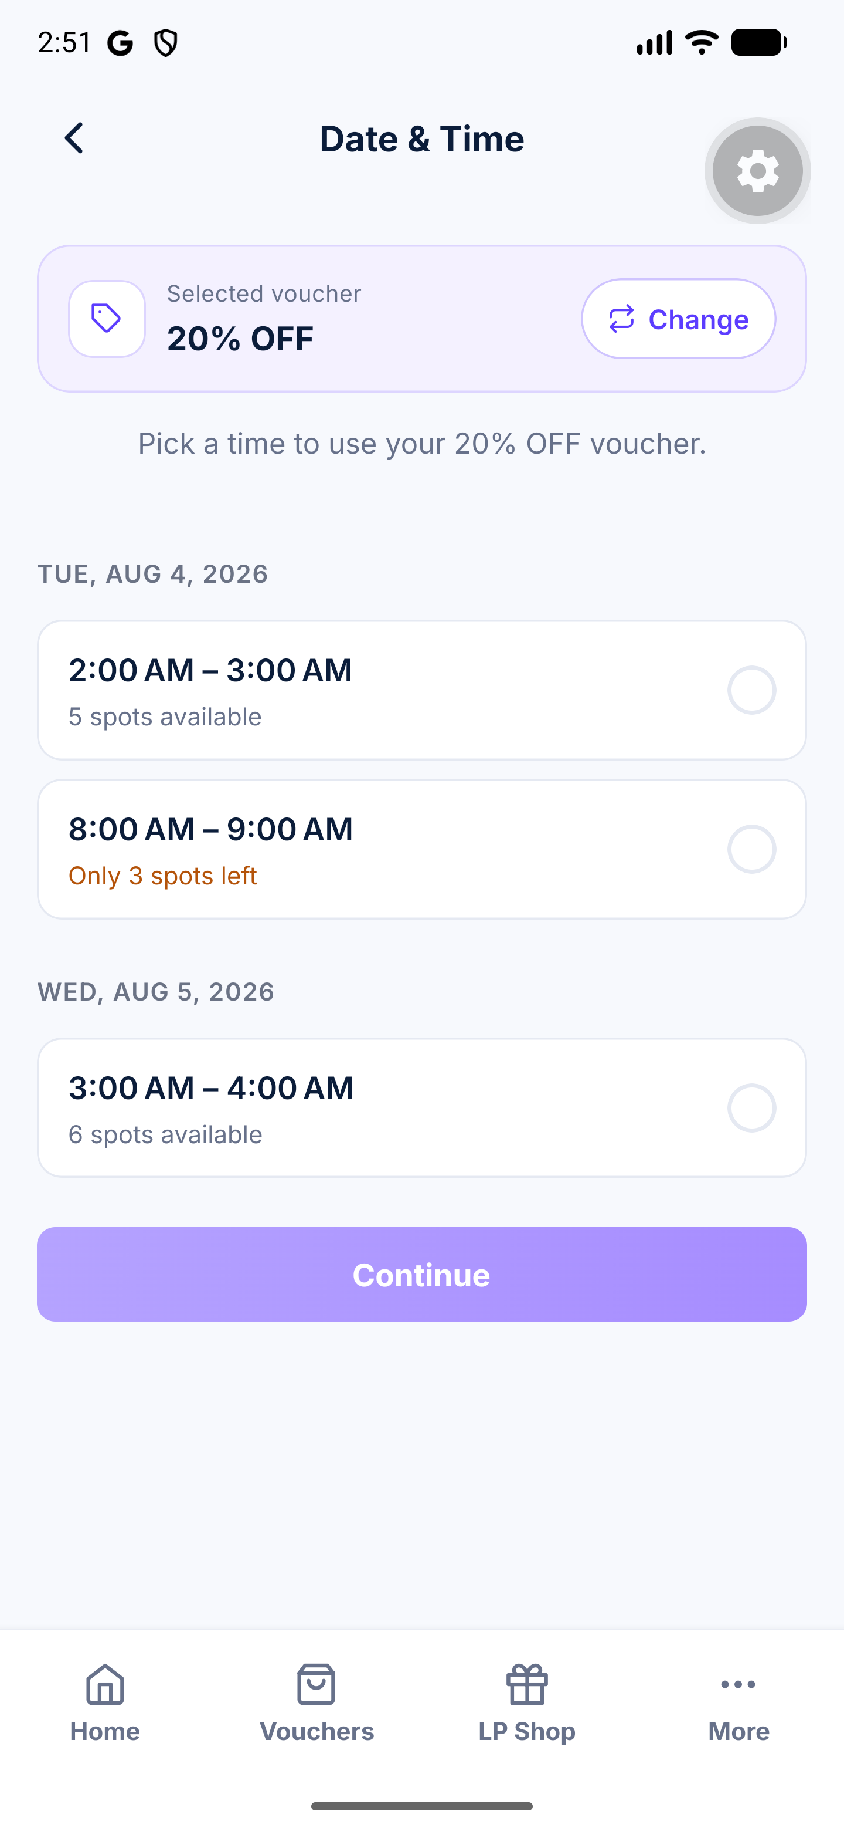
Choosing a date and time slot

Step 6 — Confirm
The customer confirms and immediately receives:
- a voucher code (for example BIZ-6C1927) and a QR code in the app,
- a confirmation SMS with the discount, the date and the time,
- a reminder in the app's Vouchers tab, where it stays until it is used.
The seat is now reserved and the prize is deducted from your stock. One voucher per customer, per campaign.
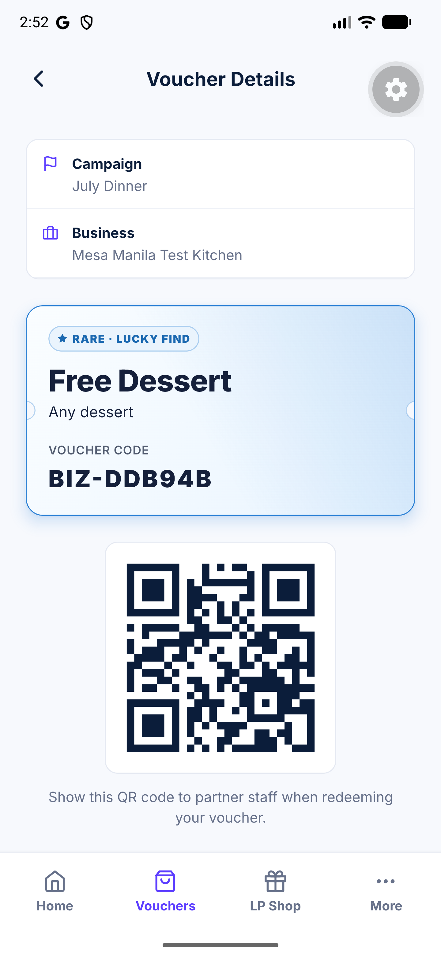
The issued voucher, with its QR code

Part 2 — At the counter
Your staff need a phone, tablet or laptop, the dashboard, and their own sign-in — an email address and password we create for each person, rather than a shared code. There is nothing to install.

Step 1 — Take the code
The customer shows their QR code, or reads out the voucher code. Your staff scan it or type it into Scan & Redeem. The screen immediately shows whether it is genuine: the discount, the customer's name, the booked date and time, and whether it has already been used. An expired or already-used voucher is refused on the spot.
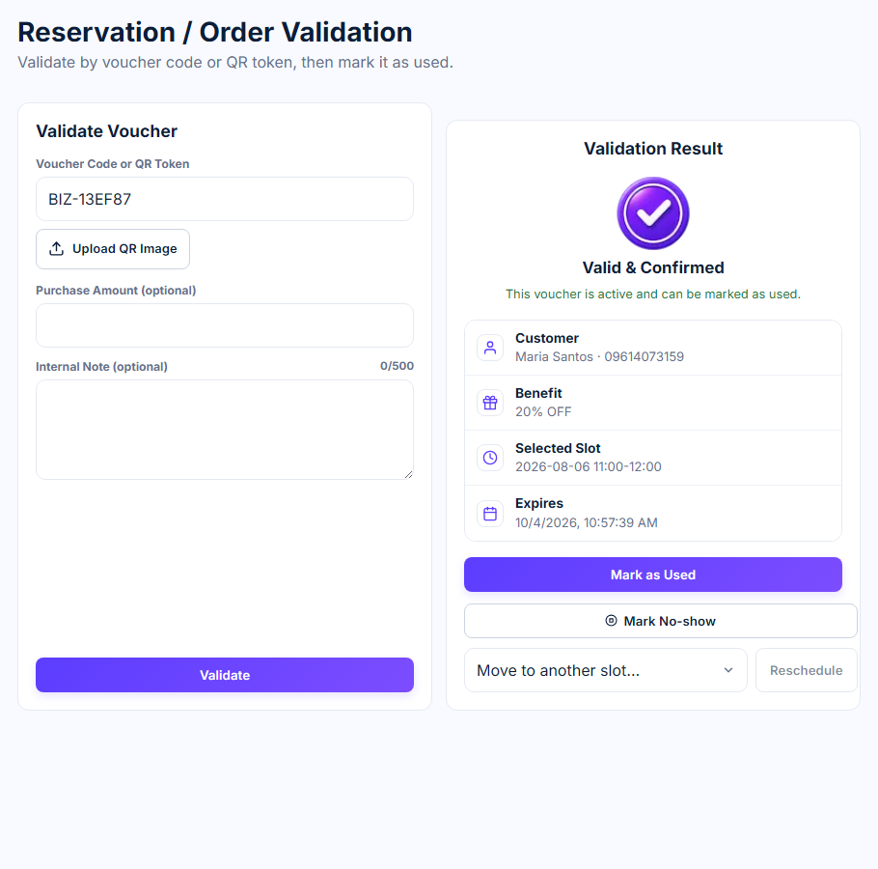
Scan & Redeem, with a code entered

Step 2 — Enter the amount they paid
Your staff apply the discount as normal on your own till, then enter the amount the customer actually paid and confirm. That is the whole job — one screen, two fields.

Step 3 — The 5% is awarded automatically
The moment the voucher is marked as used, the app works out 5% of what was paid and credits it to the customer's Loyalty Points wallet. ₱1,000 paid becomes 50 LP. Your staff see the confirmation on screen, and the customer sees the new balance in their app.
- No second scan, and nothing for your staff to remember.
- A customer earning for the first time gets a wallet automatically.
- The same sale can never be counted twice, however often the screen is retried.
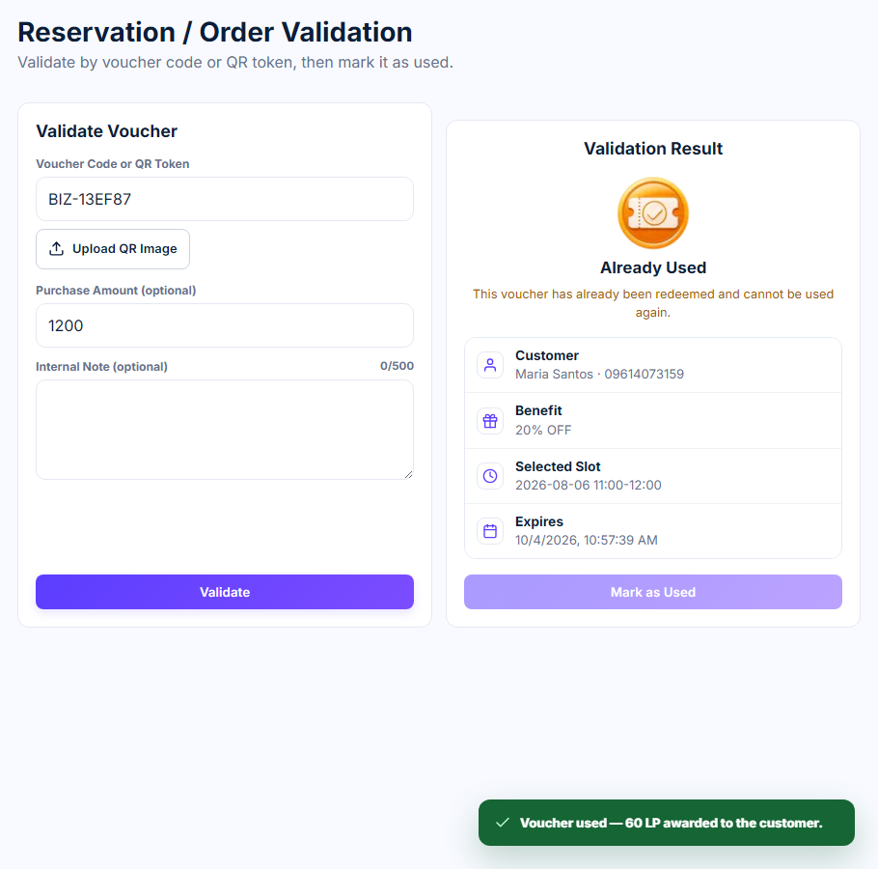
The 5% confirmed at the counter

What Loyalty Points mean for you
Loyalty Points are a shared currency across every partner in the network, and they bring customers back.
- When you award points, you owe the network their peso value — 50 LP issued costs you ₱50.
- When a customer spends points with you, the network owes you — 500 LP spent earns you ₱500.
- At the end of each month the two are netted against each other. If you owe more than you are owed, the difference comes out of your deposit. If you are owed more, we pay you the difference, less a 10% service fee.
Every partner keeps a ₱5,000 minimum deposit with the network. Your dashboard shows the running total at any time — what you owe, what you are owed, and the deposit behind both. You can also list items customers buy with points instead of money: a dessert for 150 LP, a facial for 1,200 LP. They pay in the app and collect at your counter, and the network pays you the peso value.

What you get out of it
Fill the quiet hours | Discounts are only bookable in the slots you open.
No wasted stock | You set how many of each prize exists. When it is gone, it is gone.
Real bookings | Every voucher is tied to a verified mobile number and a specific time.
They come back | Points earned with you are spendable across the network — and with you.
You see everything | Redemptions, no-shows, sales value, and what you owe or are owed.

Common questions
Can a customer use one voucher twice?
No. It is marked used the moment your staff confirm it, and the app refuses it after that.
What if they do not show up?
Staff can mark the booking a no-show. The slot is freed and it is recorded against that customer.
What if a customer wins something we cannot serve that day?
Close the slot or the tier in your dashboard and it stops being offered immediately.
Do we need new hardware?
No. Any phone, tablet or laptop with a browser.
What if we forget to enter the amount paid?
The voucher is still marked used, but no Loyalty Points are awarded for that sale. The amount is what the 5% is calculated from.

